|  |  |  |  |  |
| --- | --- | --- | --- | --- |
| C:\Users\Dell\Desktop\ReactjsInstallation\Automation Studio.png | | |  | Installation guideline on Windows |
|  |
|  |  | |
|  |  |  |
|  |  | |
|  |  | <https://www.linkedin.com/in/pravesh-jha-33013155> |
|  |  | |
|  |  | <Pravesh28@gmail.com> |
|  |  | |
|  |  |  |
|  |  | |  |

## Prerequisite Software

1. Node JS

(Reference: <https://nodejs.org/en/download/>)

1. Web server for Chrome Extension

(Reference: <https://chrome.google.com/webstore/detail/web-server-for-chrome/ofhbbkphhbklhfoeikjpcbhemlocgigb?hl=en>)

1. URL Rewrite Extension

(Reference: <https://www.iis.net/downloads/microsoft/url-rewrite>)

## Host Automation Studio on IIS Step by Step:

1. Download Automation studio from github.
2. Create any folder on your device and place the downloaded folder inside it. Over here I created a folder (AutomationStudio) in My C drive and place the download folder inside it.

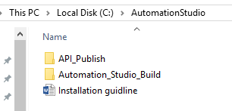

1. Launch Web server for chrome.
2. Select Reports folder (C:\AutomationStudio\Automation_Studio_Build\Automation_Resources\Reports) from Web Server Chrome.

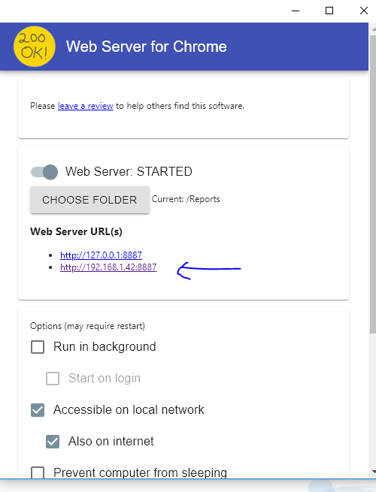

1. Note down Web Server URL (IP)
2. Open Web.config file from C:\AutomationStudio\API_Publish folder.

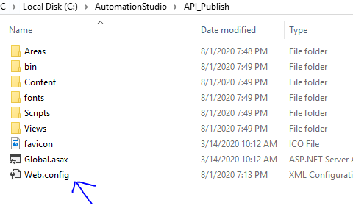

1. Update RectjsDir key with value : (C:\AutomationStudio\Automation_Studio_Build\Automation_Resources\)
2. Update ReportPublishURL key with value (Web server URL)

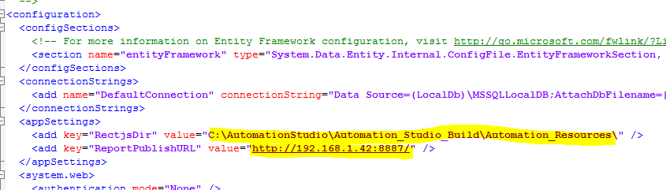

1. Add new Site in IIS (select any name automationstudioapi, port number 49957 and select set Physical path =C:\AutomationStudio\API_Publish

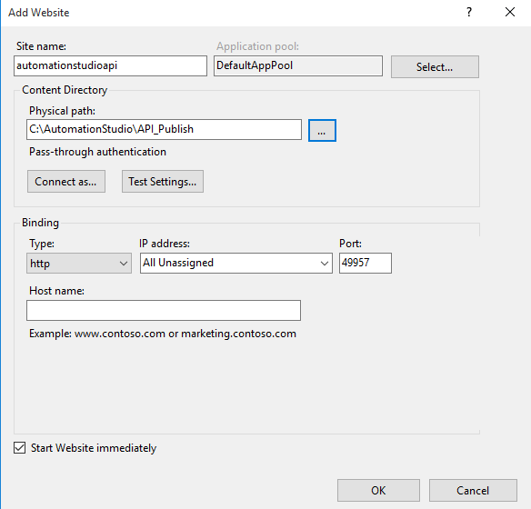

1. Note down API URI : (<http://MachineIPAdrress:49957/>)
2. Open ServerAddress.js file from C:\AutomationStudio\Automation_Studio_Build\build folder.

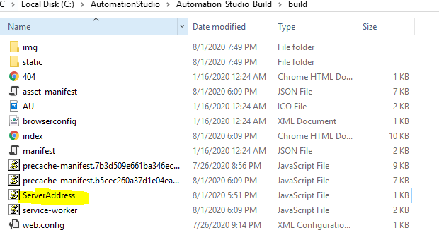

1. Update APIURL : <http://MachineIPAdrress:49957/api/> and ReportURL : IP (web server for chrome)
2. Add new site from IIS (sitename=Automationstudio,Physicalpath= C:\AutomationStudio\Automation_Studio_Build\build , Port Number =3001)

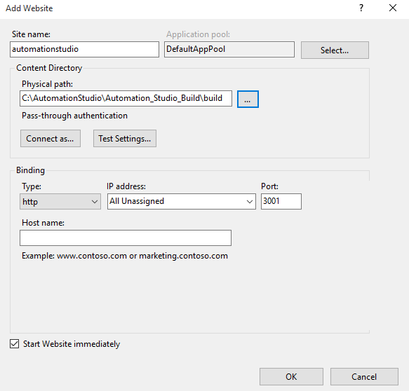

1. Browse your application using IP or local host ☺

## Browser driver set up:

1. Check browser version on your machine.
2. Download Respective chromedriver and geckodriver

(Reference: <https://chromedriver.chromium.org/>)

(Reference: <https://github.com/mozilla/geckodriver/releases>)

1. Save this browser driver under \ Automation_Studio_Build\Automation_Resources\SeleniumDLL folder.

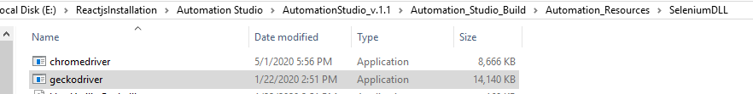

## Selenium Grid Set Up:

1. Open jsonHubRegister.bat file in Notepad from path \Automation_Studio_Build\Automation_Resources\Selenium_Grid_Configuration

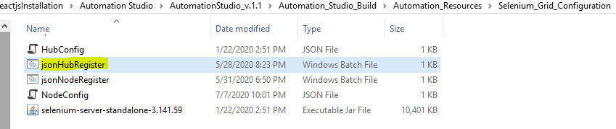

1. Update Home Path : home path will be absolute path

Downloaded Automation studio path\Automation_Studio_Build\Automation_Resources\Selenium_Grid_Configuration



1. Open jsonNodeRegister.bat file in Notepad from path

\Automation_Studio_Build\Automation_Resources\Selenium_Grid_Configuration

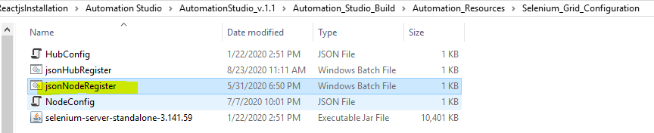

1. Update HomePath and MiscPath

Home Path = Your Parent folder +Automation_Studio_Build\Automation_Resources\Selenium_Grid_Configuration\

MiscPath= Your Parent folder+\Automation_Studio_Build\Automation_Resources\SeleniumDLL

